**17/8/17 Completed Tasks**

**1st Step: Filtering/Cleaning**

* Download CSV database provided by Michael
* Create python script to filter images from csv database
* New csv database contains - (carpart, image urls) as tuples.

**2nd Step: Label schema**

* Problem: Labels for pictures vary alot
* 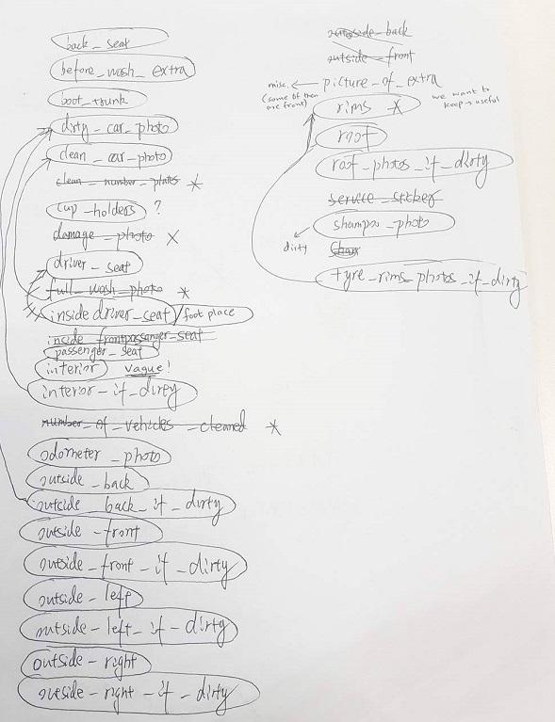
* Labels circled are the ones we are considering on keeping. (*) indicates that there are not enough images in this label/category (<20). Arrows show merging of labels.

**3rd Step: OpenCV Image Processing**

* read image by url & resize all image to equal size
* save the resized image and get RGB matrix of each images